附件1：

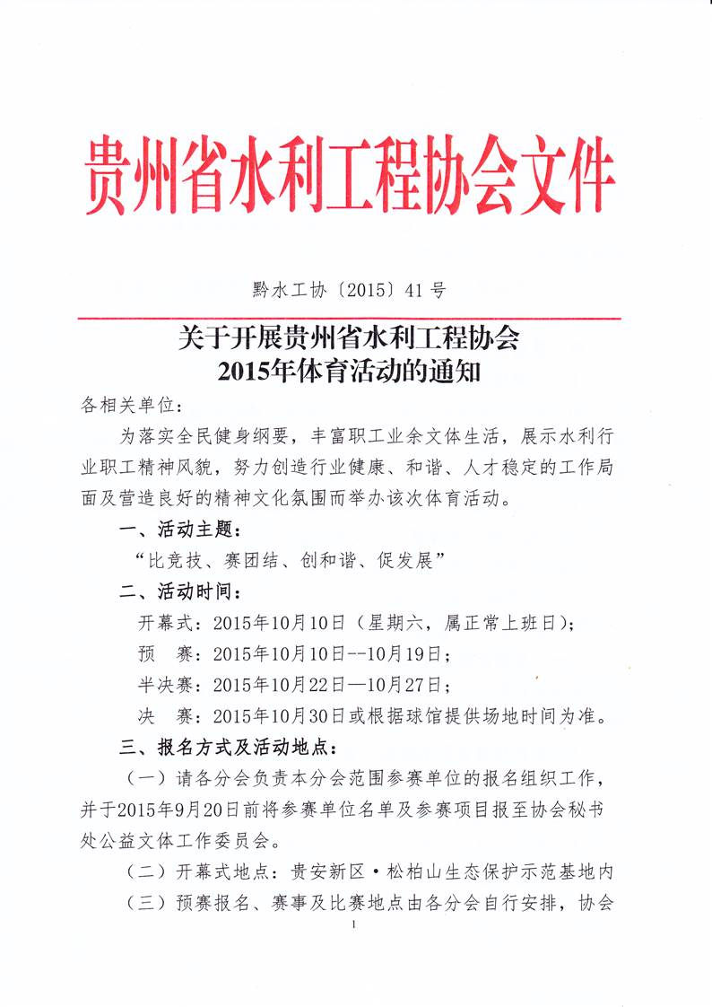

附件1：

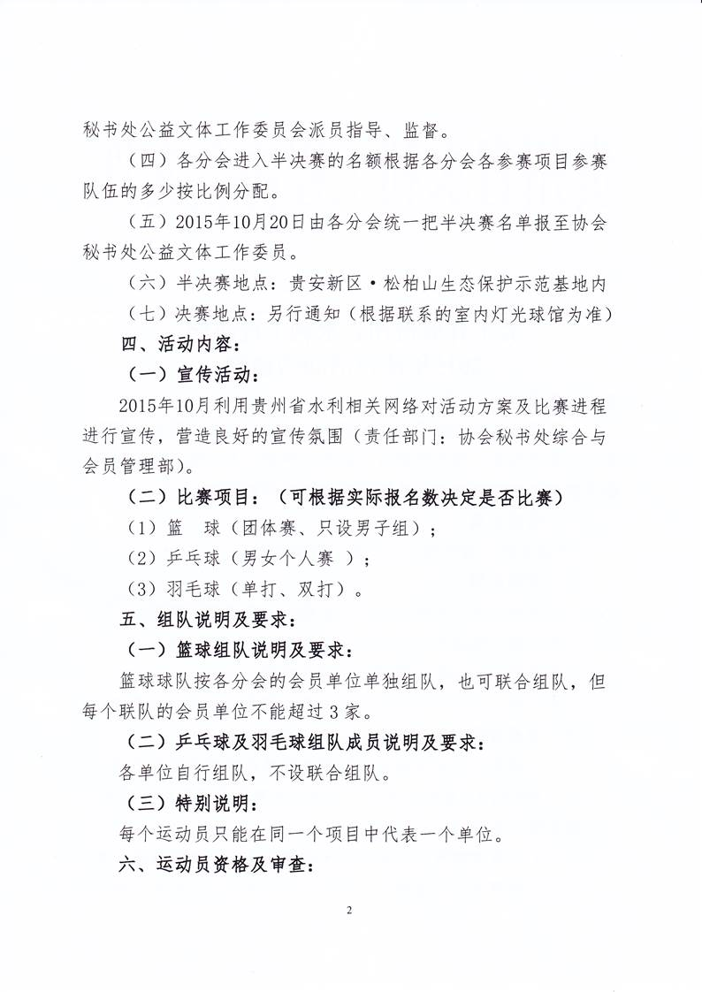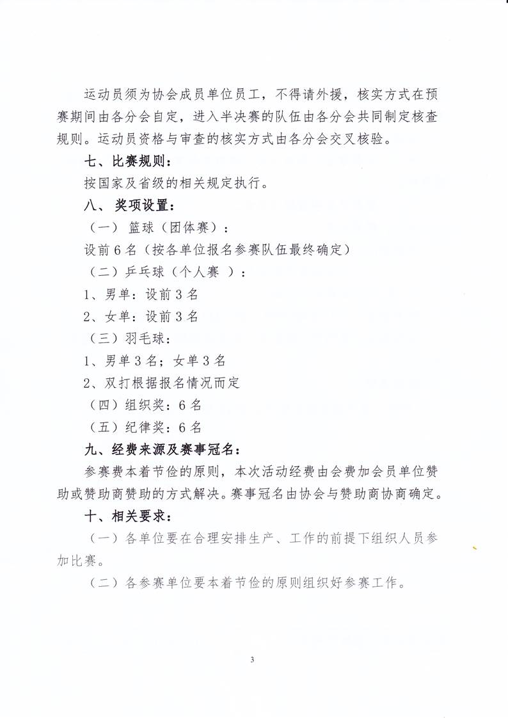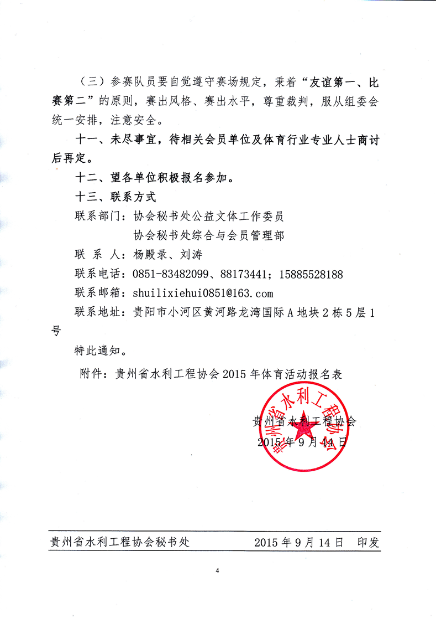

附件1

贵州省水利工程协会2015年体育活动篮球报名表

企业名称： 企业类别： 参赛所属分会：

|  |  |  |  |
| --- | --- | --- | --- |
| 序号 | 球员姓名 | 身份证号码 | 备注 |
|  |  |  |  |
|  |  |  |  |
|  |  |  |  |
|  |  |  |  |
|  |  |  |  |
|  |  |  |  |
|  |  |  |  |
|  |  |  |  |
|  |  |  |  |
|  |  |  |  |
|  |  |  |  |
|  |  |  |  |
|  |  |  |  |
|  |  |  |  |
|  |  |  |  |
|  |  |  |  |
|  |  |  |  |
|  |  |  |  |
|  |  |  |  |
|  |  |  |  |

填写时间： 填写人： 联系电话：

附件2

贵州省水利工程协会2015年体育活动乒乓球报名表

企业名称： 企业类别： 参赛所属分会：

|  |  |  |  |  |
| --- | --- | --- | --- | --- |
| 序号 | 姓名 | 性别 | 身份证号码 | 备注 |
|  |  |  |  |  |
|  |  |  |  |  |
|  |  |  |  |  |
|  |  |  |  |  |
|  |  |  |  |  |
|  |  |  |  |  |
|  |  |  |  |  |
|  |  |  |  |  |
|  |  |  |  |  |
|  |  |  |  |  |
|  |  |  |  |  |
|  |  |  |  |  |
|  |  |  |  |  |
|  |  |  |  |  |
|  |  |  |  |  |
|  |  |  |  |  |
|  |  |  |  |  |
|  |  |  |  |  |
|  |  |  |  |  |
|  |  |  |  |  |
|  |  |  |  |  |
|  |  |  |  |  |
|  |  |  |  |  |

填写时间： 填写人： 联系电话：

附件3

贵州省水利工程协会2015年体育活动羽毛球报名表

企业名称： 企业类别： 参赛所属分会：

|  |  |  |  |  |
| --- | --- | --- | --- | --- |
| 序号 | 姓名 | 性别 | 身份证号码 | 备注 |
|  |  |  |  |  |
|  |  |  |  |  |
|  |  |  |  |  |
|  |  |  |  |  |
|  |  |  |  |  |
|  |  |  |  |  |
|  |  |  |  |  |
|  |  |  |  |  |
|  |  |  |  |  |
|  |  |  |  |  |
|  |  |  |  |  |
|  |  |  |  |  |
|  |  |  |  |  |
|  |  |  |  |  |
|  |  |  |  |  |
|  |  |  |  |  |
|  |  |  |  |  |
|  |  |  |  |  |
|  |  |  |  |  |
|  |  |  |  |  |
|  |  |  |  |  |
|  |  |  |  |  |
|  |  |  |  |  |

填写时间： 填写人： 联系电话：